# 1 Where is python plugin installed in QGIS 3.4?

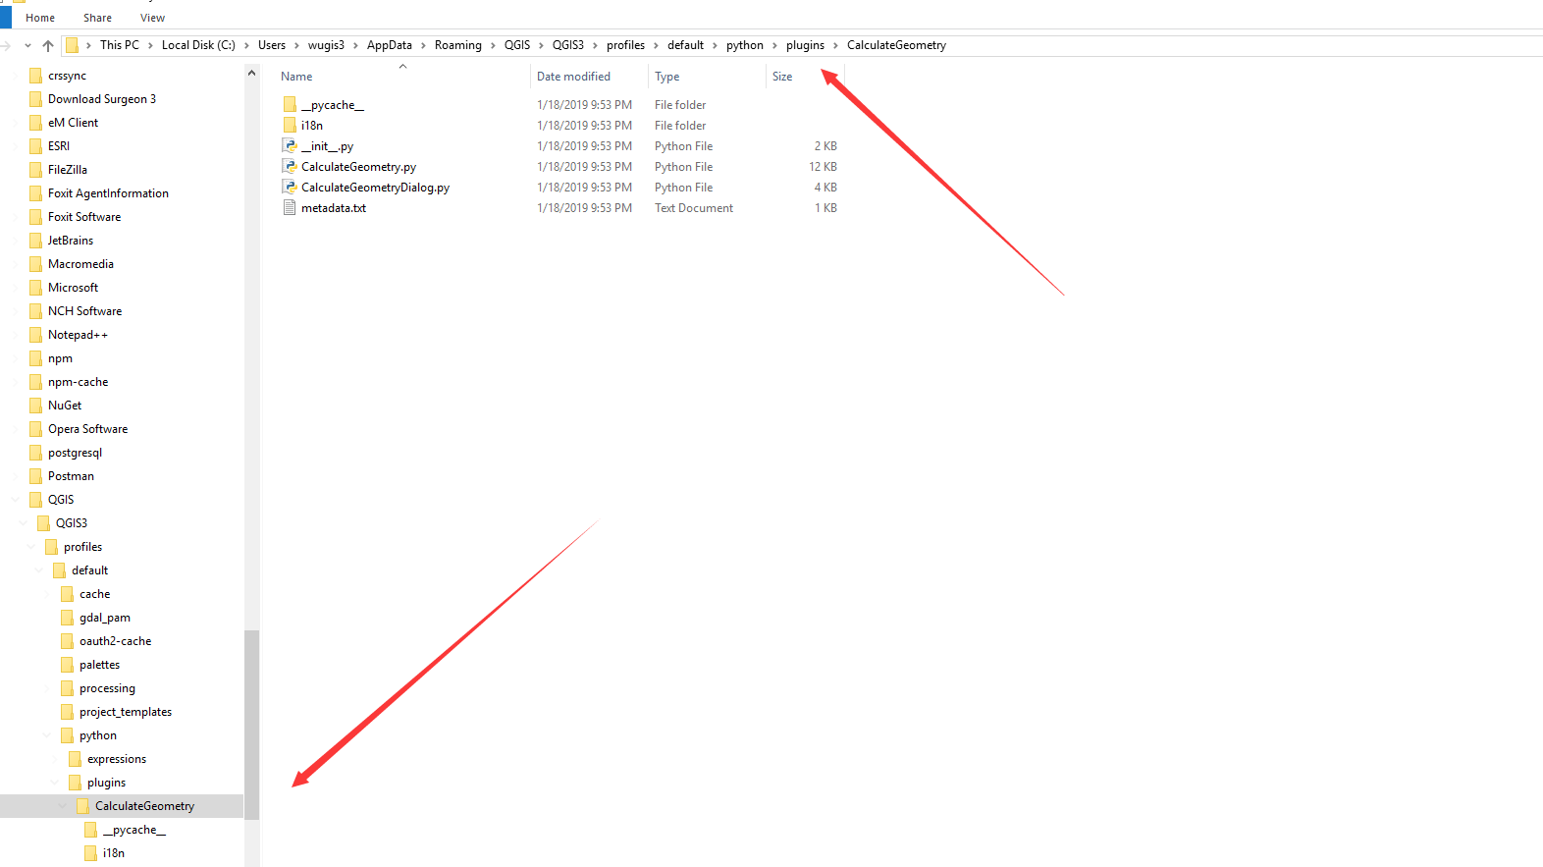

C:\Users\wugis3\AppData\Roaming\QGIS\QGIS3\profiles\default\python\plugins

# 2 How to configure QGIS python plugin dev in PyCharm for QGIS 3.4

Install QGIS 3.4

Copy qgis.bat and rename it pyQGIS.bat.

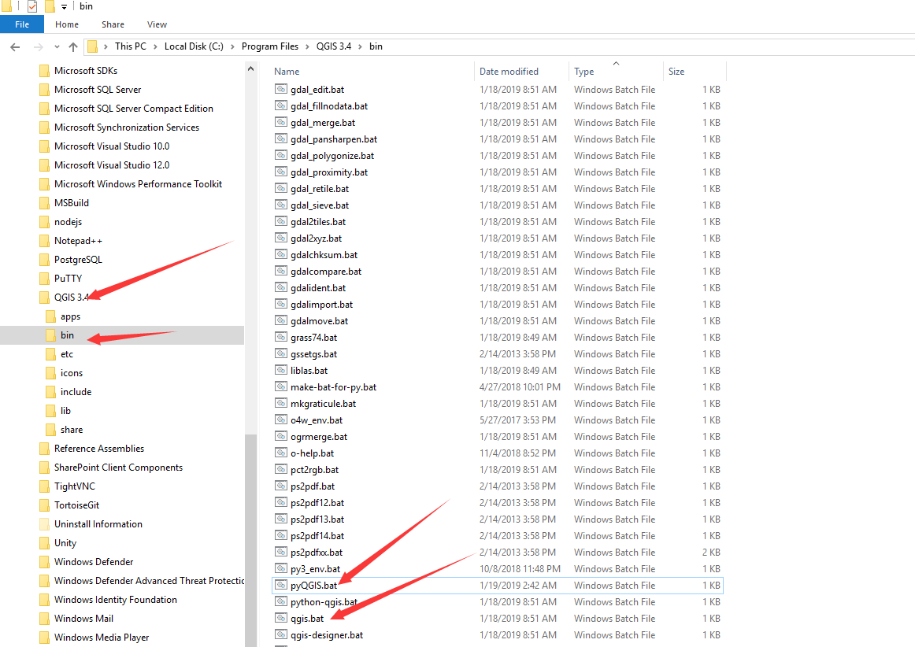

Then copy followings.

@echo off

call "%~dp0\o4w_env.bat"

call qt5_env.bat

call py3_env.bat

@echo off

path %OSGEO4W_ROOT%\apps\qgis\bin;%PATH%

set QGIS_PREFIX_PATH=%OSGEO4W_ROOT:\=/%/apps/qgis

set GDAL_FILENAME_IS_UTF8=YES

rem Set VSI cache to be used as buffer, see #6448

set VSI_CACHE=TRUE

set VSI_CACHE_SIZE=1000000

set QT_PLUGIN_PATH=%OSGEO4W_ROOT%\apps\qgis\qtplugins;%OSGEO4W_ROOT%\apps\qt5\plugins

set PYTHONPATH=%OSGEO4W_ROOT%\apps\qgis\python;%PYTHONPATH%

SET PYCHARM="C:\Program Files (x86)\JetBrains\PyCharm 5.0\bin\pycharm.exe"

start "PyCharm aware of QGIS" /B %PYCHARM% %*

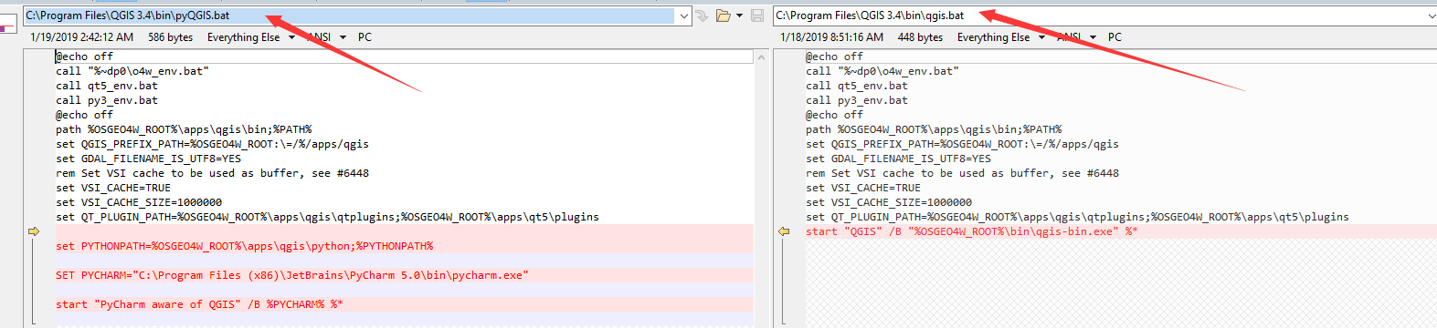

Start pyQGIS.bat.

# How to reload plugin in QGIS3.4?

Select Plugins/Manage and Installed Plugins…

